**Exercise 2: Writing Basic JUnit Tests:**

Greet class:

public class Greet {

     public String sayHello() {

      return "Hello";

     }

}

Junit Test Class:

import static org.junit.jupiter.api.Assertions.*;

import org.junit.jupiter.api.Test;

class TestGreet {

    @Test

    void test() {

        Greet greet=new Greet();

        assertEquals("Hi",greet.sayHello());

    }

}

Pom.xml file

<project xmlns="http://maven.apache.org/POM/4.0.0" xmlns:xsi="http://www.w3.org/2001/XMLSchema-instance" xsi:schemaLocation="http://maven.apache.org/POM/4.0.0 https://maven.apache.org/xsd/maven-4.0.0.xsd">

<modelVersion>4.0.0</modelVersion>

<groupId>junit</groupId>

<artifactId>Junit5setup</artifactId>

<version>0.0.1-SNAPSHOT</version>

<dependencies>

<dependency>

<groupId>org.junit.jupiter</groupId>

<artifactId>junit-jupiter-api</artifactId>

<version>5.12.0</version>

<scope>test</scope>

</dependency>

</dependencies>

</project>

Output:

1.

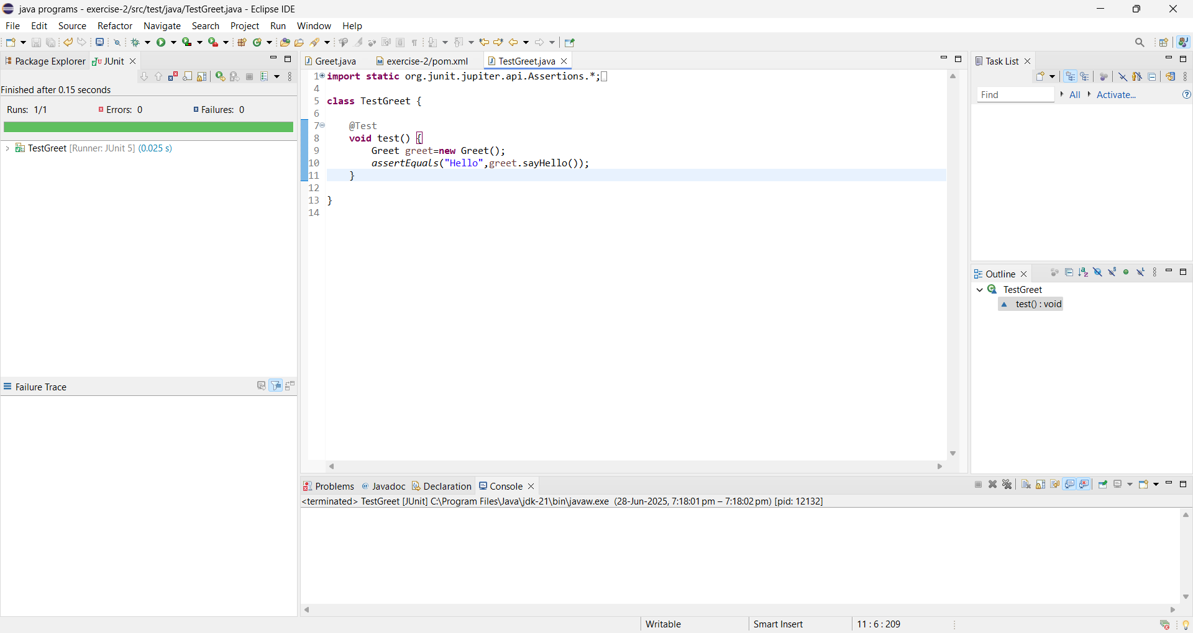

2.

